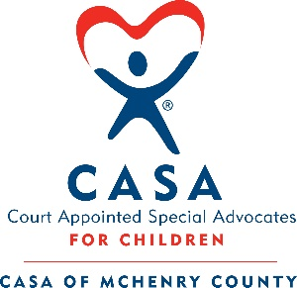

Like all organizations, schools and businesses, we are monitoring the CDC’s communication on the spread and treatment of the Coronavirus (COVID-19). The health and well-being of you, our advocates, the children we serve, their families, the CASA staff and our partner stakeholders is paramount.

With this in mind, we have decided to cancel our in-person Light of Hope event that was scheduled for April 14. It is still of utmost importance that we continue to educate the community on child abuse and neglect and Adverse Childhood Experiences (ACES), and we are exploring virtual options to still be able to facilitate community awareness on these pressing issues.

Please know that we continue to be here to serve abused and neglected children and the community at-large. If you are in need of assistance and do not know who to turn to, please reach out via email. The CASA office line voicemail messages are being monitored and all staff is working predominantly remotely.

Lastly, please continue to support - and perhaps increase support – to nonprofits in our community who are dealing with those who are marginalized. Many of these organizations do not receive state or federal funding, and will not be included in emergency funding measures. They need dollars to support their mission in this critical time. They also need dollars to support their staff who are working diligently to keep things going.

Thank you so much for your continued commitment to our community.

Meghan Scholnick - Executive Director
CASA Staff
CASA Board of Directors

